1. Remove entry <classpathentry kind="con" path="org.eclipse.buildship.core.gradleclasspathcontainer"/> from the file .classpath for the project.

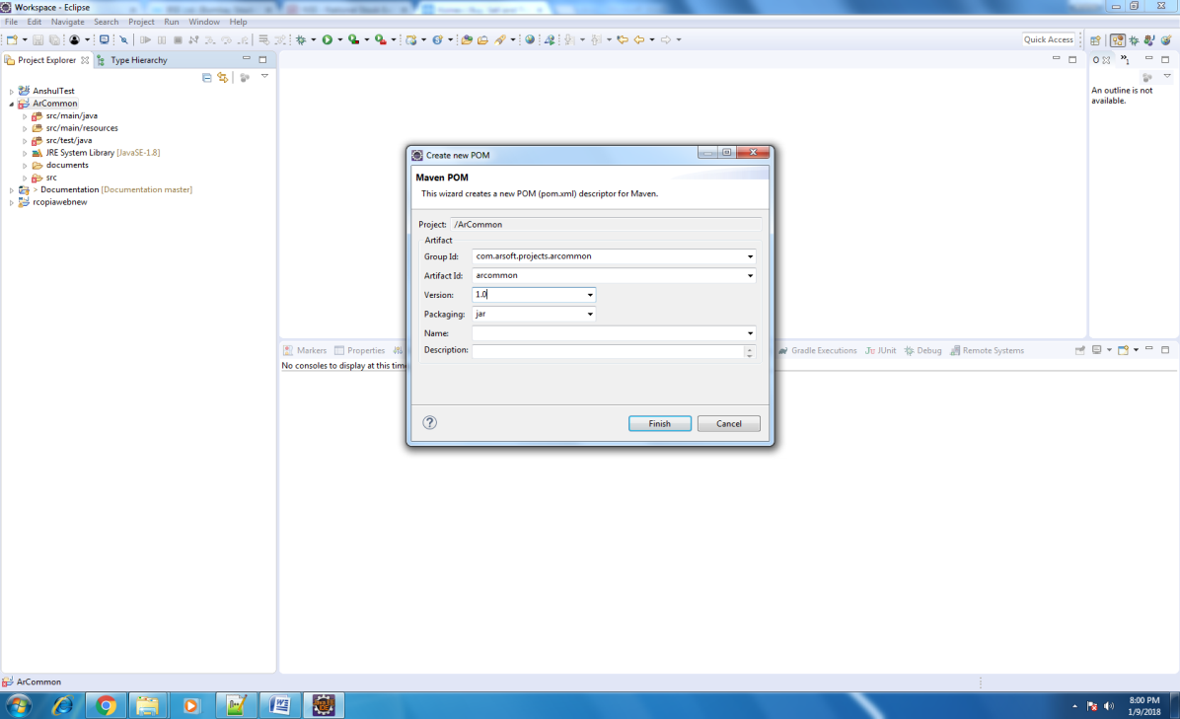

1. Click Finish.
2. This creates file pom.xml inside the root of the project.

How to fix the errors in pom.xml

Error Description:

Failure to transfer org.apache.maven.plugins:maven-surefire-plugin:pom:2.12.4 from https://repo.maven.apache.org/maven2 was cached in the local repository, resolution will not be reattempted until the update interval of central has elapsed or updates are forced. Original error: Could not transfer artifact org.apache.maven.plugins:maven-surefire-plugin:pom:2.12.4 from/to central (https:// repo.maven.apache.org/maven2): The operation was cancelled.

1. Right Click the project.
2. Click Maven >> Update Projects

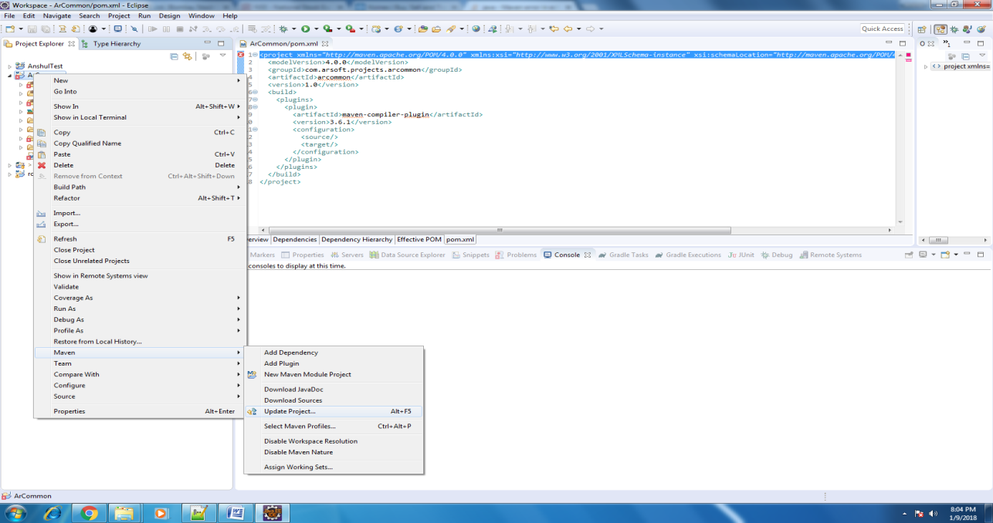

1. In the next window, select the project.
2. Check the option "Force Update of Snapshots/Releases"
3. Click "Ok"

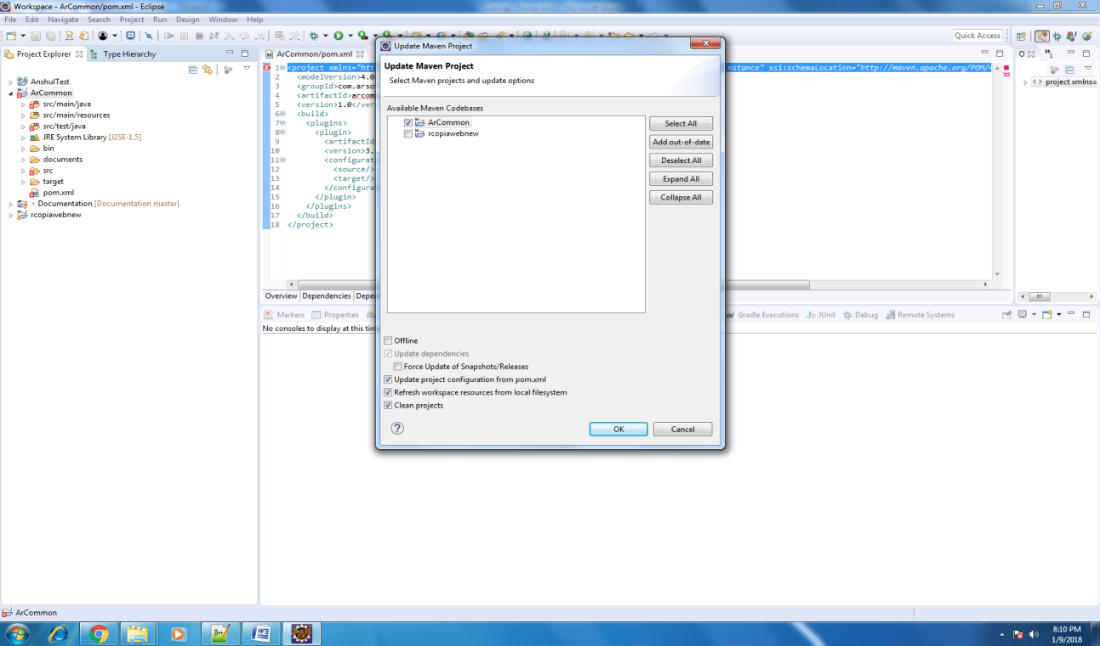

1. Right click the Project
2. Click Run As >> Maven clean
3. Click Run As >> Maven install

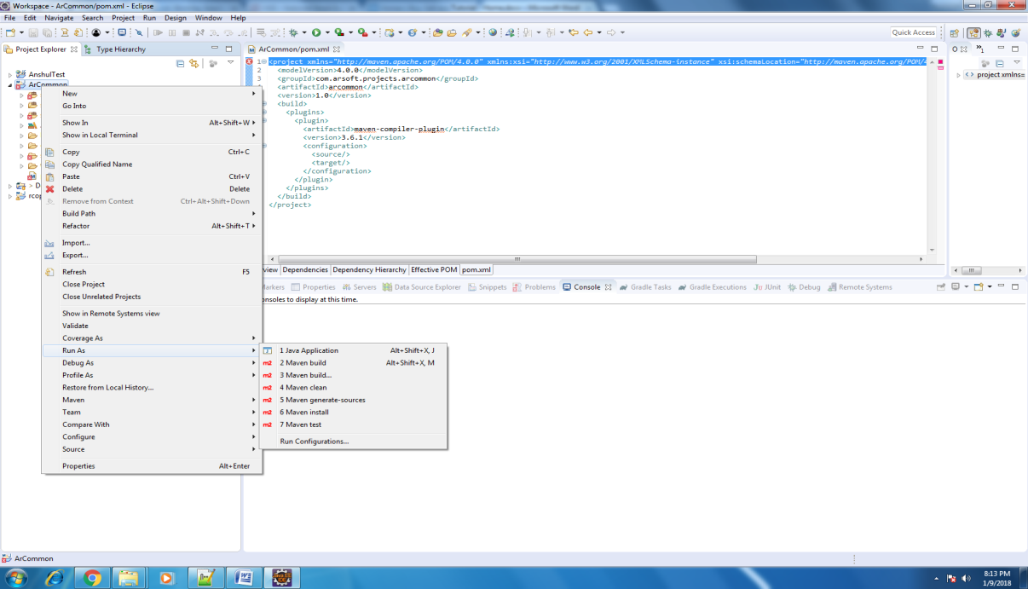



Error: Could not find or load main class org.codehaus.plexus.classworlds.launcher.Launcher

Update the m2e plug-in of the eclipse.

Update maven project using command line

mvn clean install -U

Error: Source option 1.5 is no longer supported. Use 1.6 or later

Change the compiler version of maven project

Add the below plug in to pom.xml

<plugin>

<groupId>org.apache.maven.plugins</groupId>

<artifactId>maven-compiler-plugin</artifactId>

<version>3.6.1</version>

<configuration>

<source>1.8</source>

<target>1.8</target>

</configuration>

</plugin>

or

Open pom.xml and add the below properties inside the properties tag.

<properties>

<maven.compiler.source>1.8</maven.compiler.source> <maven.compiler.target>1.8</maven.compiler.target>

</properties>